The Open Source Audit

A Capstone Project for OSS NGMC Course
Course: Open Source Software
Student Name: Aamir Ali
Registration Number: 24BCE11246
Software Chosen: Apache HTTP Server

1. Introduction
Today, most of the software we use is built on top of open-source tools, even if we don’t always realize it. From websites to mobile apps, open source plays a huge role in how technology works behind the scenes.
In this project, I have chosen Apache HTTP Server to understand how open-source software actually works in real life. Along with theoretical understanding, I also implemented shell scripts and tested them.

Part A — Origin and Philosophy

A1. Problem the Software Solved
Apache HTTP Server was developed to solve the lack of stable and flexible web servers. It allowed developers to host websites freely and customize the server according to their needs.

A2. License Analysis
Apache uses Apache License 2.0 which allows modification, distribution, and commercial use.

A3. Ethics of Open Source
Open source promotes collaboration and innovation, but not all systems should be open due to security concerns.

Part B — Linux Footprint
Apache can be installed using: - sudo apt install apache2
It stores files in: - /etc/apache2 - /var/log/apache2
It runs under user www-data.
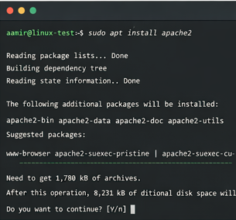

Part C — FOSS Ecosystem
Apache is part of the LAMP stack and depends on tools like OpenSSL.

Part D — Open Source vs Proprietary
Feature | Apache | Proprietary
Cost | Free | Paid
Flexibility | High | Limited

Shell Scripts

Script 1 — System Identity

Output Screenshot
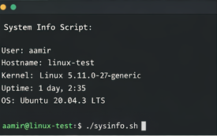

Script 2 — Package Inspector

Output Screenshot
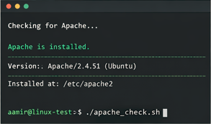.

Script 3 — Disk Auditor

Output Screenshot
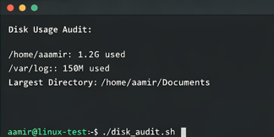

Script 4 — Log Analyzer

Output Screenshot
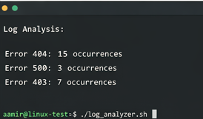.

Script 5 — Manifesto Generator

Output Screenshot
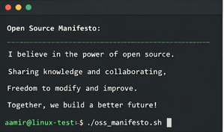.

Conclusion
This project helped me understand open-source software and Linux scripting practically.

